Assignment 1: Dimensionality Reduction using PCA

Display each digit.

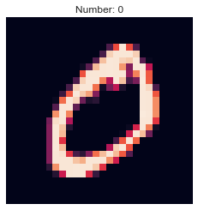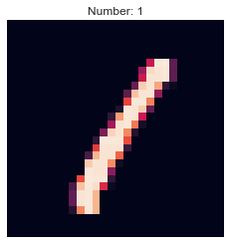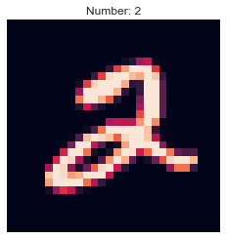

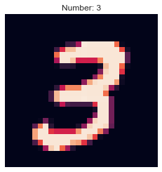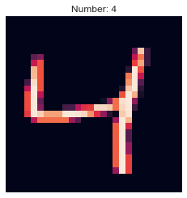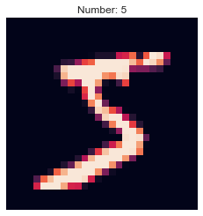

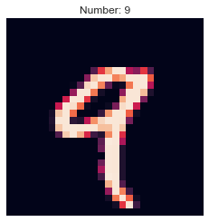

Use PCA to retrieve the principal component and output their *explained variance ratio*

*First Principal Component:*

*[ 1.56732868e-17 3.07855956e-19 -4.21453962e-19 -9.99412993e-20*

*-9.82042876e-21 1.92127580e-19 -5.05407662e-22 -6.02948903e-21*

*-2.27492997e-22 4.47828676e-23 -1.49948754e-24 0.00000000e+00*

*-9.45607456e-07 -3.72372523e-06 -1.83966299e-06 -7.66526245e-08*

*0.00000000e+00 0.00000000e+00 0.00000000e+00 0.00000000e+00*

*0.00000000e+00 0.00000000e+00 0.00000000e+00 0.00000000e+00*

*0.00000000e+00 0.00000000e+00 0.00000000e+00 0.00000000e+00*

*0.00000000e+00 0.00000000e+00 0.00000000e+00 0.00000000e+00*

*2.16821229e-07 4.29486387e-07 4.87705357e-06 1.65228560e-05*

*2.20358936e-05 3.88800851e-05 7.40593155e-05 8.83226978e-05*

*8.08470440e-05 8.95669382e-05 1.06174446e-04 7.93583533e-05*

*3.60808519e-05 3.08090913e-05 2.39080158e-05 3.64600133e-06*

*-2.94150493e-06 1.88461665e-06 1.14902285e-06 4.83369710e-07*

*0.00000000e+00 0.00000000e+00 0.00000000e+00 0.00000000e+00*

*0.00000000e+00 0.00000000e+00 1.71353699e-06 9.42410580e-07*

*3.40969919e-06 4.85814042e-08 2.87487138e-05 7.30557518e-05*

*1.77420835e-04 3.68521463e-04 5.75864297e-04 9.40411884e-04*

*1.45561381e-03 2.13480950e-03 2.64498178e-03 2.75302713e-03*

*2.62854198e-03 2.16715089e-03 1.44466762e-03 9.12320245e-04*

*5.35466205e-04 2.34552216e-04 1.03779033e-04 3.08899803e-05*

*8.67720151e-06 3.42198250e-06 0.00000000e+00 0.00000000e+00*

*0.00000000e+00 0.00000000e+00 2.28564391e-06 6.83062025e-06*

*1.48465342e-05 6.33102450e-05 1.05236408e-04 2.19779578e-04*

*5.18590872e-04 1.08767935e-03 1.93459928e-03 3.21325488e-03*

*5.00337591e-03 7.16009087e-03 9.07709859e-03 1.01293066e-02*

*9.60086014e-03 7.59327647e-03 5.54863138e-03 3.69639674e-03*

*2.30887171e-03 1.13276796e-03 5.63563755e-04 1.78020346e-04*

*2.80283620e-05 6.45206711e-07 -3.63076343e-06 0.00000000e+00*

*0.00000000e+00 1.45371051e-07 -4.28687510e-06 1.40903373e-05*

*4.95237201e-05 1.85108868e-04 4.80499017e-04 1.09255234e-03*

*2.47599696e-03 4.97085183e-03 8.58294386e-03 1.34622399e-02*

*1.89890979e-02 2.44322687e-02 2.81797754e-02 3.10833258e-02*

*3.08986917e-02 2.66576440e-02 2.09677744e-02 1.47269308e-02*

*8.93260547e-03 5.00854419e-03 2.46376406e-03 9.79980720e-04*

*2.58405352e-04 1.19280789e-05 -1.04261875e-05 -2.84063193e-06*

*0.00000000e+00 -1.89008408e-09 3.48873563e-06 1.53630521e-05*

*2.00934639e-04 6.98160779e-04 1.61130299e-03 3.52514539e-03*

*7.25709766e-03 1.37836726e-02 2.30665995e-02 3.47044178e-02*

*4.57383448e-02 5.28406351e-02 5.54862742e-02 5.55295460e-02*

*5.47762325e-02 5.18737420e-02 4.59853770e-02 3.70493801e-02*

*2.57592904e-02 1.55629338e-02 7.94935161e-03 3.22164347e-03*

*8.99326268e-04 1.47247782e-05 -7.41567944e-06 -4.86563477e-06*

*0.00000000e+00 -9.84661010e-08 -4.10558964e-06 2.55719164e-05*

*4.45050893e-04 1.32811190e-03 2.85082621e-03 6.49568917e-03*

*1.33209679e-02 2.53026024e-02 4.15677256e-02 5.88213320e-02*

*6.95737622e-02 6.99829059e-02 6.26497702e-02 5.47823420e-02*

*5.21710799e-02 5.56994452e-02 5.94980422e-02 5.70615073e-02*

*4.66469580e-02 3.10746374e-02 1.62265490e-02 6.21806362e-03*

*1.45834337e-03 2.79668926e-05 -5.36767518e-05 -1.93042989e-05*

*-5.46736745e-07 -8.73905286e-06 -3.04724883e-05 1.11263430e-05*

*4.62209670e-04 1.41808522e-03 3.61164068e-03 9.21613430e-03*

*2.00959888e-02 3.71419143e-02 5.65755487e-02 7.15954534e-02*

*7.33300482e-02 6.03860169e-02 4.06991121e-02 2.44697403e-02*

*2.12248774e-02 3.18044332e-02 4.92258010e-02 6.13305197e-02*

*6.00212320e-02 4.50896631e-02 2.55011343e-02 9.26881783e-03*

*1.49917996e-03 -2.48867192e-04 -1.18621112e-04 -1.52340149e-05*

*-2.80694918e-06 -1.19040034e-05 -4.17131133e-05 1.17582919e-05*

*4.33047465e-04 1.36711585e-03 4.70303136e-03 1.32964370e-02*

*2.87130763e-02 4.84750107e-02 6.56580813e-02 7.15893644e-02*

*6.13933838e-02 3.74401897e-02 8.87313171e-03 -1.18076269e-02*

*-1.47541863e-02 6.08283955e-04 2.91158925e-02 5.62513996e-02*

*6.67667979e-02 5.59449175e-02 3.43614339e-02 1.29678491e-02*

*1.61051593e-03 -6.88426683e-04 -1.96153006e-04 -2.15132327e-05*

*-6.61090979e-06 -2.27954100e-05 -3.88714663e-05 3.85613906e-05*

*5.08621795e-04 2.14738064e-03 8.13150736e-03 2.13214014e-02*

*4.07614129e-02 6.10774217e-02 7.16546701e-02 6.66513104e-02*

*4.70885759e-02 1.72506145e-02 -1.59555291e-02 -3.84411338e-02*

*-4.05386999e-02 -2.19960700e-02 1.29400983e-02 5.04134576e-02*

*7.00729278e-02 6.49262315e-02 4.33416865e-02 1.83280446e-02*

*3.00180587e-03 -5.83861018e-04 -1.60283105e-04 -2.68666540e-05*

*-8.25513663e-06 -1.57300776e-05 5.73695232e-06 1.67245795e-04*

*1.01090715e-03 4.58511248e-03 1.47728362e-02 3.33970877e-02*

*5.62563198e-02 7.34801088e-02 7.47505841e-02 6.08116580e-02*

*3.67163822e-02 4.26678131e-03 -3.10717568e-02 -5.35798755e-02*

*-5.24785839e-02 -3.17537448e-02 6.51220149e-03 4.90968665e-02*

*7.35336704e-02 7.15661187e-02 5.14428890e-02 2.47329523e-02*

*5.72134672e-03 -1.56755329e-04 -1.00776242e-04 -1.78810638e-05*

*-4.59363154e-06 -1.65707056e-05 4.10788920e-05 3.22353577e-04*

*1.75049504e-03 8.30343269e-03 2.34735818e-02 4.72522322e-02*

*7.09476685e-02 8.19525749e-02 7.40051474e-02 5.41795283e-02*

*2.91372123e-02 -4.84554135e-03 -4.21740569e-02 -6.00947891e-02*

*-5.29247100e-02 -2.71270732e-02 1.24617458e-02 5.45722139e-02*

*7.82231321e-02 7.67080777e-02 5.68457875e-02 3.03058641e-02*

*8.40273895e-03 1.24430539e-04 -3.49881098e-05 -9.35207912e-06*

*-2.48411665e-06 -5.47649480e-06 4.36038451e-05 4.03331984e-04*

*2.54146065e-03 1.25338276e-02 3.33641009e-02 6.07755207e-02*

*8.20112699e-02 8.46397439e-02 6.88848818e-02 4.56707311e-02*

*2.07274651e-02 -1.64779448e-02 -5.25042735e-02 -6.23276712e-02*

*-4.58048235e-02 -1.21394179e-02 2.84771897e-02 6.50245318e-02*

*8.33574671e-02 7.95493714e-02 6.00886090e-02 3.41328718e-02*

*1.06348410e-02 3.82488154e-04 -6.87577136e-06 -6.54192047e-06*

*-1.34409636e-06 -3.64987144e-07 3.36751467e-05 3.88380751e-04*

*3.57494587e-03 1.80547197e-02 4.35283201e-02 7.21405732e-02*

*8.83441294e-02 8.17055128e-02 5.90720432e-02 3.39428457e-02*

*8.44385070e-03 -3.32140723e-02 -6.21438685e-02 -6.41188361e-02*

*-3.48445926e-02 4.99702019e-03 4.47683838e-02 7.56116189e-02*

*8.79197035e-02 8.17690534e-02 6.20258721e-02 3.62646628e-02*

*1.21054325e-02 5.44682803e-04 -3.77768263e-05 -8.35416377e-06*

*1.20693064e-07 1.25313574e-06 2.32489349e-05 3.83115582e-04*

*5.08855809e-03 2.43064209e-02 5.27604459e-02 8.04759908e-02*

*9.04398862e-02 7.56970692e-02 4.70189828e-02 2.02125297e-02*

*-7.54560814e-03 -4.98960312e-02 -7.05186779e-02 -6.48266324e-02*

*-2.53674416e-02 1.46174636e-02 5.37697514e-02 8.21795629e-02*

*9.13202001e-02 8.37318881e-02 6.25213191e-02 3.63697439e-02*

*1.26443913e-02 7.89095839e-04 -3.63292519e-05 -1.57817543e-06*

*1.61405939e-08 1.92806205e-06 2.25187602e-05 4.70431149e-04*

*7.12523502e-03 3.08716439e-02 6.07617203e-02 8.56378095e-02*

*9.05655019e-02 7.02517872e-02 3.87861528e-02 1.02449790e-02*

*-2.12342410e-02 -5.93478253e-02 -7.55225638e-02 -6.22539697e-02*

*-2.06937124e-02 1.87208635e-02 5.85210647e-02 8.60963183e-02*

*9.44158808e-02 8.47472809e-02 6.15752966e-02 3.40783731e-02*

*1.14089297e-02 8.08681619e-04 -4.43300162e-05 -8.35242471e-06*

*-1.33590708e-07 4.59375088e-07 4.39896222e-05 6.67086392e-04*

*9.45078572e-03 3.66232352e-02 6.61303845e-02 8.86782502e-02*

*9.03151634e-02 6.74704939e-02 3.46065465e-02 3.98528189e-03*

*-2.90303337e-02 -6.18293952e-02 -7.56512600e-02 -5.68091687e-02*

*-1.69990655e-02 2.50215326e-02 6.57397852e-02 9.18868771e-02*

*9.82380411e-02 8.38180240e-02 5.71551727e-02 2.90567801e-02*

*8.86075512e-03 6.07153730e-04 -8.98308850e-05 -9.56923303e-06*

*0.00000000e+00 -2.23967127e-06 6.74216050e-05 1.04278557e-03*

*1.22051999e-02 4.07277824e-02 6.86549075e-02 8.89256125e-02*

*8.84056367e-02 6.57290924e-02 3.20828325e-02 -9.16908126e-04*

*-3.26477595e-02 -6.15232456e-02 -7.00949634e-02 -4.66254040e-02*

*-4.75337773e-03 4.12325083e-02 7.98863163e-02 1.00844381e-01*

*1.00015709e-01 7.83627743e-02 4.86830838e-02 2.22883593e-02*

*5.95052941e-03 3.60186109e-04 -1.00176978e-04 -1.05004222e-05*

*-3.36329009e-06 -3.03183521e-07 1.17162242e-04 1.73804516e-03*

*1.44600054e-02 4.20502884e-02 6.85729599e-02 8.71463179e-02*

*8.65126438e-02 6.48216184e-02 3.15656648e-02 -2.48368013e-03*

*-3.24296895e-02 -5.58931700e-02 -5.55452072e-02 -2.55150577e-02*

*2.04373489e-02 6.56747135e-02 9.70839466e-02 1.07707067e-01*

*9.47125448e-02 6.65551933e-02 3.75570004e-02 1.52444659e-02*

*3.51520135e-03 1.86252091e-04 -6.31088700e-05 -1.12293095e-05*

*-5.89585246e-07 -9.01927334e-06 1.64650385e-04 2.25086692e-03*

*1.49149883e-02 4.06704948e-02 6.65807128e-02 8.52895163e-02*

*8.71654033e-02 6.95243949e-02 3.83517014e-02 5.96597272e-03*

*-2.05909454e-02 -3.60122499e-02 -2.73976967e-02 6.62315690e-03*

*5.18930721e-02 8.92146976e-02 1.07570633e-01 1.02623884e-01*

*7.94114444e-02 5.03572781e-02 2.52805991e-02 9.11092305e-03*

*1.80573188e-03 6.31233720e-05 -4.32841260e-05 -6.07875738e-06*

*0.00000000e+00 -1.07751567e-06 1.94388620e-04 2.22862853e-03*

*1.28104810e-02 3.45840530e-02 6.03666062e-02 8.13079059e-02*

*8.87943210e-02 7.89654226e-02 5.51820074e-02 2.84567636e-02*

*6.73124386e-03 -2.62645754e-03 9.94972158e-03 4.10793446e-02*

*7.65408441e-02 9.88400583e-02 1.00085044e-01 8.24854435e-02*

*5.63750417e-02 3.16423090e-02 1.41029195e-02 4.71850734e-03*

*8.85599342e-04 2.02411609e-05 -2.81141026e-05 -2.38198925e-06*

*-1.31166078e-06 4.01569161e-06 1.62164053e-04 1.72241771e-03*

*8.76523241e-03 2.46018835e-02 4.68678127e-02 6.93251953e-02*

*8.24088685e-02 8.18659253e-02 6.88579296e-02 5.01549431e-02*

*3.55492600e-02 3.02496069e-02 3.99368540e-02 6.07048112e-02*

*7.95378025e-02 8.50557557e-02 7.36305940e-02 5.31242141e-02*

*3.20418299e-02 1.59161323e-02 6.53809143e-03 2.31919783e-03*

*5.04302817e-04 3.71527836e-05 6.32065679e-06 2.08047268e-06*

*-1.27067138e-06 -5.24066775e-07 7.45407861e-05 9.37170499e-04*

*4.24135199e-03 1.28826710e-02 2.75948716e-02 4.53466185e-02*

*5.93270030e-02 6.45845659e-02 5.98584726e-02 4.94275995e-02*

*4.04126883e-02 3.71659826e-02 4.07975039e-02 4.95313666e-02*

*5.51887008e-02 5.20641147e-02 4.03541198e-02 2.61390390e-02*

*1.40135594e-02 6.47147867e-03 2.75432525e-03 1.11767830e-03*

*3.06363522e-04 4.47678589e-05 6.39096984e-06 3.84087264e-06*

*0.00000000e+00 -1.89008408e-09 1.79982827e-05 2.55443359e-04*

*1.11779667e-03 3.55863608e-03 8.73058551e-03 1.65526901e-02*

*2.46577189e-02 2.94395097e-02 2.92774043e-02 2.63235025e-02*

*2.24583055e-02 1.89548494e-02 1.75170337e-02 1.92930569e-02*

*2.14646207e-02 1.97036221e-02 1.44904161e-02 8.88072842e-03*

*4.84474767e-03 2.49784495e-03 1.12293419e-03 4.25568171e-04*

*1.08890114e-04 8.43742713e-06 -6.41064625e-06 0.00000000e+00*

*0.00000000e+00 0.00000000e+00 3.27269049e-06 2.73501151e-05*

*7.32591930e-05 1.82559341e-04 3.46341901e-04 4.80290490e-04*

*3.29841159e-04 -9.86194684e-04 -3.46176363e-03 -5.43441193e-03*

*-6.68816058e-03 -6.92355919e-03 -5.69734383e-03 -2.54194311e-03*

*5.15618212e-04 2.36062257e-03 2.74053124e-03 2.37003200e-03*

*1.69415724e-03 9.76244588e-04 4.81125731e-04 1.81905819e-04*

*2.37079384e-05 -3.73239102e-06 -1.87440372e-06 0.00000000e+00*

*0.00000000e+00 0.00000000e+00 4.14741490e-07 -6.85617654e-06*

*-6.17352368e-05 -1.90911045e-04 -5.85549805e-04 -1.51165887e-03*

*-3.38630790e-03 -6.10527312e-03 -9.28946418e-03 -1.16109532e-02*

*-1.23833710e-02 -1.16137183e-02 -9.18256832e-03 -6.32306764e-03*

*-3.39067603e-03 -1.23830983e-03 -1.56424305e-05 4.85136747e-04*

*5.39582834e-04 3.31884716e-04 1.45949877e-04 7.68743480e-05*

*1.56570640e-05 -1.10968503e-06 -1.36245595e-06 0.00000000e+00*

*0.00000000e+00 0.00000000e+00 0.00000000e+00 -8.44206893e-07*

*-2.89368798e-05 -9.34028935e-05 -2.81197837e-04 -7.08380966e-04*

*-1.54279200e-03 -2.59008512e-03 -3.77413114e-03 -4.84692778e-03*

*-5.20040396e-03 -4.76707114e-03 -3.68276625e-03 -2.34096232e-03*

*-1.34802052e-03 -7.08181455e-04 -2.59297676e-04 4.85138183e-06*

*1.06741646e-04 5.37512887e-05 1.81237615e-05 7.33774360e-07*

*6.67296310e-07 -6.57480658e-07 0.00000000e+00 0.00000000e+00*

*0.00000000e+00 0.00000000e+00 0.00000000e+00 0.00000000e+00*

*-1.76719064e-06 -7.79684335e-06 -1.97849720e-05 -4.86228788e-05*

*-5.70818895e-05 -1.01220108e-04 -2.30080511e-04 -2.82364219e-04*

*-2.97966195e-04 -2.90659042e-04 -2.63320348e-04 -1.86028260e-04*

*-9.86302032e-05 -5.50416765e-05 -2.31407815e-05 3.28960092e-06*

*-5.74901597e-07 -6.03536876e-07 -7.83847550e-07 6.50876376e-08*

*0.00000000e+00 0.00000000e+00 0.00000000e+00 0.00000000e+00]*

*---------------------------------------------------------------------*

*Second Principal Component:*

*[ 2.38165113e-16 -3.00761105e-18 1.30564872e-17 3.32180095e-18*

*4.58499037e-19 -7.07511629e-18 1.30888262e-19 1.44360321e-19*

*1.61850337e-21 1.66452679e-21 1.19064269e-22 -0.00000000e+00*

*1.53944763e-06 5.19630211e-06 2.03136841e-06 8.46403502e-08*

*-0.00000000e+00 -0.00000000e+00 -0.00000000e+00 -0.00000000e+00*

*-0.00000000e+00 -0.00000000e+00 -0.00000000e+00 -0.00000000e+00*

*-0.00000000e+00 -0.00000000e+00 -0.00000000e+00 -0.00000000e+00*

*-0.00000000e+00 -0.00000000e+00 -0.00000000e+00 -0.00000000e+00*

*2.90890728e-07 1.85375788e-06 2.62790145e-05 5.48187628e-05*

*6.54031515e-05 8.66259380e-05 1.76880398e-04 2.70509953e-04*

*3.14760712e-04 2.69430485e-04 2.46572785e-04 1.98870532e-04*

*1.54454052e-04 1.27029273e-04 7.46576169e-05 2.91640678e-05*

*8.58521855e-06 3.55787108e-06 7.94356147e-06 6.15016966e-06*

*-0.00000000e+00 -0.00000000e+00 -0.00000000e+00 -0.00000000e+00*

*-0.00000000e+00 -0.00000000e+00 -3.48812346e-08 1.04675121e-06*

*2.39662378e-06 -5.97429931e-06 3.29323772e-05 1.31693349e-04*

*2.14507365e-04 3.44678079e-04 6.73350561e-04 1.09379371e-03*

*1.52567096e-03 1.92276342e-03 2.00928518e-03 1.69388044e-03*

*1.20290236e-03 5.22127156e-04 -1.84590641e-04 -5.74083219e-04*

*-4.96455799e-04 -2.91115341e-04 -1.20616934e-04 -4.10185567e-05*

*-1.47584292e-05 -2.16213469e-06 -0.00000000e+00 -0.00000000e+00*

*-0.00000000e+00 -0.00000000e+00 -1.79218336e-06 3.33676426e-06*

*-4.39188860e-06 -4.81337900e-05 -1.75526079e-04 -3.61282745e-04*

*-8.68455041e-04 -1.67995653e-03 -2.46572694e-03 -3.55852754e-03*

*-4.56054624e-03 -5.34513175e-03 -6.09993741e-03 -7.10854256e-03*

*-7.73372152e-03 -7.75929462e-03 -6.85508394e-03 -5.36399639e-03*

*-3.34937968e-03 -1.72298361e-03 -8.03189046e-04 -2.90097120e-04*

*-1.30045196e-04 -3.06506742e-05 -6.27839087e-06 -0.00000000e+00*

*-0.00000000e+00 -1.41475310e-06 -9.34591567e-06 -6.04519931e-06*

*-8.24773954e-05 -5.29663043e-04 -1.65652950e-03 -4.06062693e-03*

*-7.96517442e-03 -1.37152457e-02 -2.11831047e-02 -2.98925159e-02*

*-3.91592444e-02 -4.93963770e-02 -5.85563403e-02 -6.44026596e-02*

*-6.40706073e-02 -5.68448942e-02 -4.41259411e-02 -3.04307779e-02*

*-1.74177878e-02 -8.44212382e-03 -3.38659207e-03 -1.17595522e-03*

*-4.93037083e-04 -1.53933950e-04 -9.80348633e-06 -1.92413131e-06*

*-0.00000000e+00 -9.21522024e-07 -8.79892589e-06 -7.33400570e-05*

*-4.82987999e-04 -1.98944522e-03 -5.29294466e-03 -1.12682344e-02*

*-2.02325694e-02 -3.19332774e-02 -4.57434741e-02 -6.04503073e-02*

*-7.59721626e-02 -9.34713044e-02 -1.09645714e-01 -1.21290850e-01*

*-1.22275770e-01 -1.10172164e-01 -8.53862807e-02 -5.70602033e-02*

*-3.18488721e-02 -1.40908157e-02 -4.04281502e-03 -3.65573886e-04*

*-2.52101133e-05 -7.99454781e-05 1.24098227e-05 -3.40998254e-06*

*-0.00000000e+00 -2.70855726e-07 1.19415769e-05 -2.02712462e-04*

*-1.00526893e-03 -3.13617934e-03 -7.78263344e-03 -1.58059152e-02*

*-2.64362494e-02 -3.70795951e-02 -4.69282802e-02 -5.54438606e-02*

*-6.32795076e-02 -7.38730797e-02 -8.75871774e-02 -1.01212380e-01*

*-1.07912143e-01 -1.02092734e-01 -8.26366162e-02 -5.59119878e-02*

*-3.12610684e-02 -1.24924676e-02 -2.19169933e-03 1.36213931e-03*

*1.12763889e-03 3.28761001e-04 1.13128567e-04 1.01173742e-05*

*2.59902972e-06 2.77877375e-05 2.04311608e-04 4.39703898e-04*

*4.44719796e-04 -2.16925656e-04 -2.47250374e-03 -6.28156106e-03*

*-9.24748474e-03 -9.24237650e-03 -4.35156773e-03 3.10846110e-03*

*7.26921438e-03 3.23698129e-03 -1.00178537e-02 -2.69643714e-02*

*-3.95337048e-02 -4.11861543e-02 -3.27837558e-02 -1.94724897e-02*

*-7.42698672e-03 -3.31424174e-04 3.48015284e-03 4.10202946e-03*

*2.18145634e-03 9.17601005e-04 2.42925740e-04 1.55396903e-05*

*1.21495123e-05 1.34211532e-04 8.27945843e-04 2.17780167e-03*

*4.08725688e-03 7.12406248e-03 9.94224306e-03 1.49194450e-02*

*2.43762921e-02 4.08805503e-02 6.03873332e-02 7.36355827e-02*

*7.41148227e-02 6.11855474e-02 3.91602670e-02 1.61691605e-02*

*3.96775080e-03 5.65893503e-03 1.52334087e-02 2.16155829e-02*

*1.98302268e-02 1.37425728e-02 7.86987142e-03 4.43069658e-03*

*2.08754757e-03 8.80084516e-04 2.60158780e-04 1.61888897e-05*

*1.64586630e-05 2.29123024e-04 1.38593405e-03 3.77872500e-03*

*7.71000357e-03 1.38386150e-02 2.19413147e-02 3.57407056e-02*

*5.71765880e-02 8.42441283e-02 1.02263794e-01 1.01411942e-01*

*8.24009960e-02 5.30890887e-02 2.12821799e-02 -3.64387262e-03*

*-6.83694393e-03 1.31944315e-02 3.94902283e-02 5.00026467e-02*

*3.86872235e-02 2.07564731e-02 7.70144116e-03 2.17319524e-03*

*8.98822446e-04 5.79805725e-04 1.69392728e-04 2.46680518e-05*

*2.52972902e-05 2.54607912e-04 1.45220883e-03 3.93318574e-03*

*8.70458125e-03 1.62868488e-02 2.78261039e-02 4.82032648e-02*

*7.74455859e-02 1.02179640e-01 1.03697020e-01 7.69169811e-02*

*3.79655010e-02 -3.82244515e-04 -3.50086071e-02 -5.30768284e-02*

*-3.74675125e-02 9.91138269e-03 5.72073602e-02 7.17721851e-02*

*5.03211900e-02 2.18027800e-02 4.31720839e-03 -1.05183289e-03*

*-2.73133761e-04 2.94556078e-04 9.56018401e-05 1.99273343e-05*

*1.56558808e-05 1.69028681e-04 1.12594121e-03 2.98903454e-03*

*7.29819622e-03 1.49071820e-02 2.89661099e-02 5.49579729e-02*

*8.62425984e-02 9.97543861e-02 7.64379674e-02 2.64233782e-02*

*-2.25932561e-02 -6.03357438e-02 -8.94204696e-02 -9.27532459e-02*

*-5.24969399e-02 2.19506422e-02 8.05604763e-02 8.69609493e-02*

*5.37573925e-02 1.84794684e-02 4.34531329e-04 -3.32794160e-03*

*-1.09942497e-03 1.47464240e-04 6.52327253e-05 6.25813409e-06*

*1.12733923e-05 9.45466010e-05 6.00331814e-04 1.90168127e-03*

*5.54400133e-03 1.31401394e-02 2.98166657e-02 5.94282462e-02*

*8.82508925e-02 8.68064122e-02 4.32072220e-02 -1.69753277e-02*

*-6.34076722e-02 -9.77415360e-02 -1.17586414e-01 -1.02777449e-01*

*-3.75322396e-02 5.04877553e-02 9.91021672e-02 8.85349569e-02*

*4.68252295e-02 1.22894399e-02 -2.71394435e-03 -4.30758476e-03*

*-1.24958271e-03 1.40068475e-04 2.97985968e-05 -1.03708323e-06*

*-5.26342300e-07 3.40909189e-05 2.69417764e-04 1.25239901e-03*

*4.59138360e-03 1.26858455e-02 3.15966044e-02 6.20397108e-02*

*8.58827385e-02 7.53913107e-02 2.73923268e-02 -2.64312644e-02*

*-6.55539153e-02 -9.83567321e-02 -1.07074195e-01 -7.56917059e-02*

*4.43085132e-03 8.11024419e-02 1.01751494e-01 7.37483096e-02*

*3.20793694e-02 5.34572715e-03 -3.82913024e-03 -3.60364143e-03*

*-7.83973816e-04 2.05904721e-04 2.53987298e-05 2.89707790e-06*

*-2.26494174e-07 5.10340996e-06 1.02384492e-04 8.93211967e-04*

*4.06156234e-03 1.21961969e-02 3.16480035e-02 5.98060689e-02*

*8.12208016e-02 7.28676908e-02 3.76262620e-02 -2.04158252e-04*

*-3.31626265e-02 -6.29423405e-02 -6.16507081e-02 -2.02977286e-02*

*5.72057454e-02 1.02633890e-01 9.19248602e-02 4.94633738e-02*

*1.46700247e-02 -9.61883802e-04 -4.01652802e-03 -2.26368838e-03*

*-1.35974850e-04 2.96198946e-04 -2.76358331e-05 -2.63653626e-06*

*2.06370518e-07 -1.28225632e-06 1.02075639e-05 6.70454689e-04*

*3.03708344e-03 9.84898351e-03 2.59147958e-02 4.91276724e-02*

*6.91666013e-02 7.04294346e-02 5.28319466e-02 2.85940198e-02*

*-1.05242673e-03 -2.20376133e-02 -1.28055817e-02 3.71366766e-02*

*9.88509133e-02 1.11874461e-01 7.45154017e-02 2.44787439e-02*

*-1.96932628e-03 -7.73161490e-03 -5.79704375e-03 -2.30118103e-03*

*-5.02261319e-05 2.88671306e-04 -6.52392891e-05 -6.41789363e-06*

*1.60304187e-06 -9.31296257e-09 -8.64606487e-05 1.24067438e-04*

*9.43134388e-04 4.13529929e-03 1.29881529e-02 2.74009078e-02*

*4.24307152e-02 4.83993470e-02 4.13908348e-02 2.28376866e-02*

*-5.87608083e-04 -8.99842988e-03 1.57126686e-02 7.46700568e-02*

*1.18307114e-01 1.04888401e-01 4.96752493e-02 6.08777279e-04*

*-1.77743692e-02 -1.59442429e-02 -9.56220038e-03 -4.21395491e-03*

*-9.38356168e-04 -1.65693195e-04 -9.13292282e-05 -8.31997778e-06*

*-0.00000000e+00 -9.14813257e-06 -1.46338609e-04 -6.83704141e-04*

*-2.13964444e-03 -4.63120654e-03 -4.80356170e-03 -1.24523406e-03*

*4.62039078e-03 8.05523901e-03 2.70555607e-03 -1.19104325e-02*

*-2.43033013e-02 -1.54650874e-02 2.89651951e-02 9.00709913e-02*

*1.14841945e-01 8.12235527e-02 2.01352863e-02 -2.14363776e-02*

*-3.14590382e-02 -2.46385176e-02 -1.48261725e-02 -7.15603937e-03*

*-2.71823967e-03 -9.38702381e-04 -1.79202584e-04 -2.10470548e-06*

*7.87668091e-07 -6.40590916e-06 -2.76162377e-04 -1.69698289e-03*

*-5.93798060e-03 -1.41419439e-02 -2.30738278e-02 -2.88652763e-02*

*-3.02551715e-02 -3.08555989e-02 -3.55850695e-02 -4.21038867e-02*

*-3.97193656e-02 -1.40601261e-02 3.89422793e-02 8.68376447e-02*

*9.04105776e-02 4.61385426e-02 -9.02013686e-03 -4.00909980e-02*

*-4.23397907e-02 -3.14963357e-02 -1.94029554e-02 -1.00369039e-02*

*-4.55663235e-03 -1.67343588e-03 -2.69884465e-04 -1.76864489e-05*

*-6.30259308e-07 -3.11616786e-06 -4.34394178e-04 -2.57131258e-03*

*-9.13930530e-03 -2.20975241e-02 -3.80172956e-02 -5.16231332e-02*

*-5.96591270e-02 -6.31189392e-02 -6.42650797e-02 -6.00856868e-02*

*-4.35638639e-02 -7.61597149e-03 3.96029507e-02 6.57920446e-02*

*5.07088189e-02 7.21102437e-03 -3.39395469e-02 -5.17385879e-02*

*-4.71828417e-02 -3.41339447e-02 -2.05457608e-02 -1.04980736e-02*

*-4.87741887e-03 -1.69370373e-03 -2.45446289e-04 -1.27126551e-05*

*-0.00000000e+00 -1.57605351e-05 -5.51613826e-04 -3.09681307e-03*

*-1.04920861e-02 -2.54062174e-02 -4.59516983e-02 -6.72274306e-02*

*-8.43547378e-02 -9.34641497e-02 -9.26677018e-02 -7.97066565e-02*

*-5.29873266e-02 -1.50501493e-02 1.86663461e-02 2.72592905e-02*

*7.52776307e-03 -2.33797579e-02 -4.71248099e-02 -5.17289841e-02*

*-4.25288345e-02 -2.88574432e-02 -1.66847520e-02 -8.48891036e-03*

*-4.06363183e-03 -1.23126865e-03 -1.75175462e-04 -1.60921857e-06*

*-1.16844413e-06 -1.61891736e-05 -5.06916350e-04 -2.66585471e-03*

*-9.09497404e-03 -2.28087511e-02 -4.48778717e-02 -7.13791246e-02*

*-9.70654566e-02 -1.14371881e-01 -1.17459160e-01 -1.02956786e-01*

*-7.33328777e-02 -3.86010706e-02 -1.46518842e-02 -1.04418310e-02*

*-2.08598570e-02 -3.39180515e-02 -4.03992832e-02 -3.65392579e-02*

*-2.70534067e-02 -1.71283542e-02 -9.48953123e-03 -5.13905148e-03*

*-2.47845058e-03 -5.98252503e-04 -6.35972062e-05 -9.50057909e-07*

*-1.13193025e-06 -1.86335719e-06 -3.01432757e-04 -1.63637987e-03*

*-5.69077310e-03 -1.50856957e-02 -3.24021519e-02 -5.68782993e-02*

*-8.40014769e-02 -1.05420539e-01 -1.12862286e-01 -1.01736005e-01*

*-7.66604771e-02 -4.88548366e-02 -2.89805611e-02 -1.96893380e-02*

*-1.65974822e-02 -1.56798584e-02 -1.52342029e-02 -1.19782630e-02*

*-8.19353682e-03 -5.24319578e-03 -3.28043459e-03 -1.86349841e-03*

*-9.08215945e-04 -1.70702369e-04 -1.59401470e-05 -1.75395306e-06*

*-0.00000000e+00 -9.21522024e-07 -9.00527835e-05 -6.01780890e-04*

*-2.22149043e-03 -6.13588154e-03 -1.42281233e-02 -2.77255640e-02*

*-4.46855452e-02 -5.87948956e-02 -6.35263749e-02 -5.40932878e-02*

*-3.48648991e-02 -1.50834867e-02 4.74804362e-04 1.06364942e-02*

*1.54353844e-02 1.54331650e-02 1.15995650e-02 7.45936176e-03*

*4.17393335e-03 1.59912551e-03 4.05545990e-04 9.37163418e-05*

*-3.30396327e-05 7.56804736e-06 -8.22876107e-06 -0.00000000e+00*

*-0.00000000e+00 -0.00000000e+00 -8.75157917e-06 -1.14733018e-04*

*-3.72275469e-04 -8.61095247e-04 -1.66890748e-03 -2.45506565e-03*

*-2.08240333e-03 9.07258409e-04 9.25957711e-03 2.17922942e-02*

*3.47201549e-02 4.25294594e-02 4.50071147e-02 4.28245124e-02*

*3.70482860e-02 2.89058310e-02 1.95177016e-02 1.19351073e-02*

*6.55490963e-03 3.03666264e-03 1.28015837e-03 5.73228907e-04*

*1.27737019e-04 2.52467406e-05 1.35358400e-06 -0.00000000e+00*

*-0.00000000e+00 -0.00000000e+00 1.95903688e-06 7.22823294e-06*

*5.84292714e-05 4.14176232e-04 1.53200367e-03 4.04194423e-03*

*9.10030853e-03 1.67709838e-02 2.71446425e-02 3.73347123e-02*

*4.45734091e-02 4.61638679e-02 4.23717547e-02 3.52580317e-02*

*2.79863374e-02 2.01519579e-02 1.28056238e-02 7.43339544e-03*

*3.85226088e-03 1.73391105e-03 7.32859458e-04 2.89943603e-04*

*7.08192862e-05 1.11496858e-05 1.76472566e-06 -0.00000000e+00*

*-0.00000000e+00 -0.00000000e+00 -0.00000000e+00 -6.98414148e-08*

*2.95258966e-05 2.47729855e-04 9.83896918e-04 2.41400658e-03*

*5.14606954e-03 8.59649651e-03 1.31056449e-02 1.76065474e-02*

*2.02327034e-02 2.01194125e-02 1.79896565e-02 1.40922286e-02*

*1.08374112e-02 7.49924953e-03 4.52520025e-03 2.58813690e-03*

*1.37137409e-03 5.64790794e-04 1.81143432e-04 5.67166779e-05*

*2.50518873e-06 1.51096328e-06 -0.00000000e+00 -0.00000000e+00*

*-0.00000000e+00 -0.00000000e+00 -0.00000000e+00 -0.00000000e+00*

*4.00350086e-06 2.92872677e-05 8.24737491e-05 2.05247814e-04*

*3.37144976e-04 5.54725966e-04 9.37041334e-04 1.27051630e-03*

*1.63428643e-03 1.87818619e-03 2.15797239e-03 1.85074099e-03*

*1.39894374e-03 8.74950974e-04 4.87328962e-04 2.32454142e-04*

*1.07553660e-04 3.02851146e-05 1.81077893e-05 1.90031536e-06*

*-0.00000000e+00 -0.00000000e+00 -0.00000000e+00 -0.00000000e+00]*

*/--------------------------------------------------------------------*

*Explained Variance Ratio:*

*[0.09746116 0.07155445]*

***Plot the projections of the first and second principal components onto a 1D hyperplane***

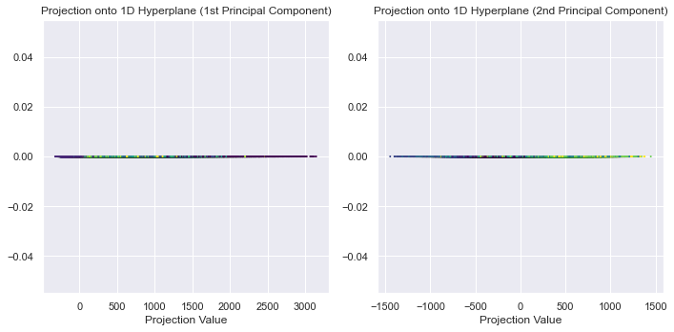

*Use Incremental PCA to reduce the dimensionality of the MNIST dataset down to 154 dimensions*

*Display the original and compressed digits from (5)*

**

*Question 2*

*Plot the resulting generated Swiss roll dataset.*

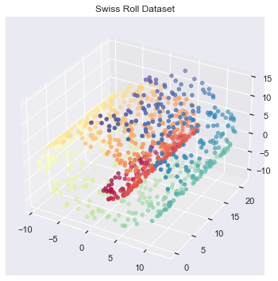

***Plot the kPCA results of applying the linear kernel (2 points), a RBF kernel (2 points), and a sigmoid kernel (2 points) from (3). Explain and compare the results***

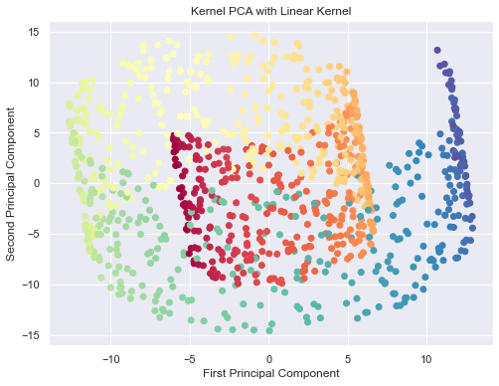

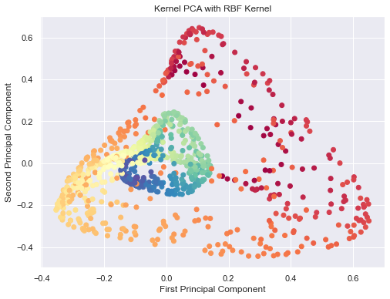

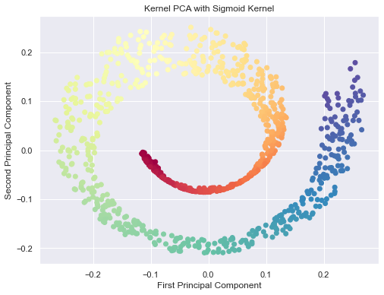

***Using kPCA and a kernel of your choice, apply Logistic Regression for classification. Use GridSearchCV to find the best kernel and gamma value for kPCA in order to get the best classification accuracy at the end of the pipeline. Print out best parameters found by GridSearchCV***

*Best Parameters: {'kpca__gamma': 0.03, 'kpca__kernel': 'sigmoid'}*

*Test Accuracy: 0.725*

***Plot the results from using GridSearchCV***

